Computational Approaches for Identifying Effective Treatments for Pediatric Brain Tumors

Project overview: We propose to study the most common pediatric brain tumor, medulloblastoma (MB). Although some children who suffer from MB go on to lead a healthy life after surgery and radiation, some children do not respond to this treatment and succumb to this disease. Therefore, we are trying to find safe and effective therapies for those patients. One of the main issues with brain tumors is that tumors are made up of many different cells and this makes it difficult to ascertain which cells to try to eliminate with a drug. We have developed a way to find this out based on RNA sequencing of each cell individually within MB tumors. We will use novel computational approaches we developed to identify FDA approved drugs to target the cells in medulloblastoma and test these drugs in preclinical models of MB.

Scientific approach: MB has been classified into four major subgroups: WNT, SHH, Group 3 and Group 4, each with its own histology, molecular drivers and prognoses. We have developed a computational pipeline to identify therapeutic combinations in a patient specific manner. This pipeline, termed SynergySeq, allows us to stratify patients based on the tumor makeup. We have used this pipeline effectively for glioblastoma (GBM), the most common adult brain tumor, to make predictions that were confirmed in preclinical models. We are now applying this same computational pipeline to pediatric brain tumors.

Specific Aim: Use SynergySeq to analyze RNA sequencing data from MB tumors in order to identify FDA approved compounds that are predicted to correct disease states. Test the therapeutic efficacy of hit compounds in mice implanted orthotopically with patient-derived MD cells. Completion of this aim will provide a comprehensive list of FDA approved compounds that can be used individually and in combination for the treatment of MB.

Update on progress and new directions: The principal investigator, Dr. Nagi Ayad has accepted a position at Georgetown University, but continues to make progress toward completion of the proposed work in collaboration with Dr. Zane Zeier, Associate Professor and member of the Sylvester Comprehensive Cancer Center at UM. Drs. Ayad and Zeier have a productive collaborative research program that combines their complementary expertise in animal and in vitro preclinical model systems, respectfully. Dr. Zeier’s laboratory has developed new human brain model systems that are increasingly utilized as a host for brain tumors including GBM(1) and MB(2). Using accessible skin or blood cells, Dr. Zeier’s laboratory has generated induced pluripotent stem cells that can be used to produce small (~1mm) human brain-like tissues called brain organoids. This miniature human brain model can be used as a surrogate host for resected or PDX brain tumor cells (Figure 1). Important advantages of brain organoid systems are: the ability to serve as a screening platform, the opportunity for personalized medicine, the ability to modify and analyze sub-populations of cells longitudinally, the retention of spatial and morphological information, the ability to analyze human-specific genetic determinates of disease, and the ability to recapitulate tumor ecosystems involving radiation, chemotherapy, hypoxia, cytokines, and necrosis.

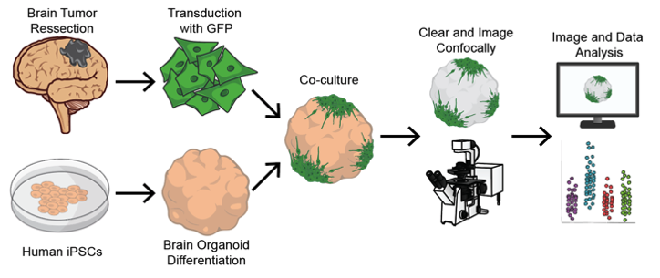
Figure 1. Schematic of organoid-based brain tumor models (not to scale)

Animal studies are inherently low-throughput and so it would be too costly and laborious for Dr. Ayad to test all the predicted SynergySeq hits and combinations of hits in animals. To narrow the experimental therapies to be tested in animals, Dr. Zeier will first conduct a screen using cerebellar organoids co-cultured with MB cells. Using an image-based assay to assess compound efficacy, Dr. Zeier will inform Dr. Ayad’s animal studies as originally proposed. Drs. Ayad and Zeier have successfully implemented this new technology for GBM and will adapt the system to MB to facilitate completion of the original aim.

1. M. J. Rybin, M. E. Ivan, N. G. Ayad, Z. Zeier, Organoid Models of Glioblastoma and Their Role in Drug Discovery. Front Cell Neurosci 15, 605255 (2021).
2. C. Ballabio et al., Modeling medulloblastoma in vivo and with human cerebellar organoids. Nat Commun 11, 583 (2020).

